THE PRISON YAARD DILEMMA:
HOW AGENTS COOPERATE IN A 2-D SPACE

BY
BOLAND UNFUG

A Thesis
Submitted to the Division of______________
New College of Florida
in partial fulfillment of the requirements for the degree
Bachelor of Arts (Single space all of this)
Under the sponsorship of _______________________
Sarasota, Florida
Month, Year

Acknowledgement
I extend my deepest gratitude to my professors, whose guidance and unwavering support kept me on track throughout the duration of this project. Their insights and expertise were indispensable in shaping the direction and execution of my research. Special thanks are owed to Professor Fahmida Hamid for her invaluable assistance in the early stages of program development. Her support and encouragement were crucial during the foundational phase of my work, helping to set the trajectory for the subsequent research and analysis.
I am equally thankful to my friends, who not only suggested innovative tactics and maneuvers that enriched my approach but also dedicated their time to rigorously check my work. Their constructive critiques and thoughtful feedback were crucial in refining my analysis and enhancing the overall quality of this study.
Special inspiration was drawn from the seminal works of notable scholars in the field. the pioneering computer tournament by Robert Axelrod offered a robust framework for understanding strategic interactions, which was pivotal in framing my hypotheses.

Table of Contents
Acknowledgement 3
Abstract 5
Introduction 6
The prisoner’s dilemma 6
The iterated prisoner’s dilemma 9
Axelrod’s Tournament 10
Implementation 13
Concept 13
Implementation 19
Results 30
Conclusion 36
Works Cited 38

THE PRISON YAARD DILEMMA:
HOW AGENTS COOPERATE IN A 2-D SPACE
Boland Unfug
New College of Florida, 2024-25

Abstract
The prisoner’s dilemma and its variations offer profound insights into conflict and cooperation, captivating researchers across disciplines. Yet, a mutation of this classic game involving physical agents in a two-dimensional discrete environment remains largely unexplored. To explore this new facet of the prisoner’s dilemma, I developed a computer simulation using C++, Python, Box2D, and SFML that can simulate up to 1000 agents, uses deterministic, reproducible physics, and provides users with a complete history of the results. I designed this tool with the intention to discover if movement strategies were more impactful than gameplay decision rules, and to see if Tit For Tat remains robust in a simulated physical environment. This thesis details the design and development process of the program, along with an analysis of some of the program’s results. This tool promises to open new avenues in the analysis of prisoner dilemma variants involving more dynamic settings.
Thesis Advisor
Computer Science

Introduction

The prisoner’s dilemma
Game theory is a cornerstone of applied mathematics, exerting a profound influence on diverse fields such as economics, biology, and psychology. Among its many constructs, the prisoner's dilemma is notably the most renowned, celebrated for its extensive real-world applications and historical significance. Originally developed by Merrill Flood and Melvin Dresher in 1950 (Poundstone, 1992, p. 8) to explore decision making conflicts involving individual and communal interest, it was formalized by Albert W. Tucker (Poundstone, 1992, p. 117), who coined the term "prisoner's dilemma" and introduced the scenario with two criminals suspected of a crime.

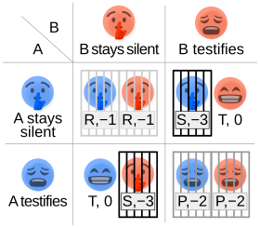
1
(Poundstone, 1992, p. 118; “Prisoner’s Dilemma,” 2024)

In Poundstone’s model, as seen in the illustration above, two potential prisoners, A and B, are arrested by the police. Having been caught trespassing, each can be sent to jail for a minimum of 1 year. Once at the station, they are taken to separate rooms, where each is given an ultimatum. If you testify against your friend, and they stay silent, you will go free while your friend spends 3 years in prison. However, if both you and your friend testify, you both go to jail for 2 years. Lastly, if neither you nor your friend testify, we will send you to jail for the minimum 1 year sentence.
Each prisoner now faces a difficult choice, to stay silent and hope their friend does as well, or to testify, potentially lowering their maximum sentence. The most mutually favorable outcome for both parties occurs when they each decide to cooperate by remaining silent, thereby receiving the minimum sentence. However, from a mathematical perspective the individual’s most rational choice is to defect, as testifying reduces both the potential minimum and maximum sentences. for instance, if Criminal A remains silent, they risk a one-year sentence but could potentially face three years if Criminal B betrays them. Conversely if Criminal A testifies against Criminal B the worst possible outcome is a 2-year sentence with a chance of complete exoneration. This is exacerbated by the fact that each participant can assume that the other is likely to reach the same conclusion, causing the tendency to testify to reinforce itself, as each seeks to protect themselves against their friend’s defection. Consequently, despite the optimal strategy of cooperation for the communal benefit, the rational calculations of the individuals lead them to defect, ultimately resulting in harsher penalties for both. This paradox, though rooted in a simple theoretical scenario, has profound implications for how agents will act in my own simulation.

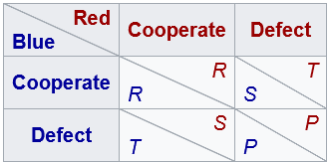
(“Prisoner’s Dilemma,” 2024)

In order to understand how the prisoner’s dilemma is used in the simulation, we must look at the generalized version of the prisoner’s dilemma. Most prisoners’ dilemma involves 2 agents that can make 2 choices. In the example model above, the two agents are labeled as 'Red' and 'Blue', and each have the option to either 'Cooperate' or 'Defect'. The outcomes of their decisions are represented by four possible payoffs: the Reward for mutual cooperation (R), the Punishment for mutual defection (P), the Temptation to defect (T), and the Sucker's payoff (S). For a scenario to qualify as a true prisoner's dilemma, the payoffs must satisfy the inequality T > R > P > S, indicating that defection is individually rational but leads to a poorer outcome if both parties choose to defect, compared to mutual cooperation.

The iterated prisoner’s dilemma
The result of mutual defection in the prisoner’s dilemma stems from the fact that the game is only played once. When multiple iterations are played, one after the other with the same individuals, cooperation can evolve (Poundstone, 1992, p. 109). The ability to remember past outcomes allows agents to react much more dynamically than in the prisoner’s dilemma. This dynamism opens an entirely new dimension of decision-making strategies, referred to as ‘tactics’ in this thesis.
One notable limitation of the iterated prisoner’s dilemma arises when players have knowledge of the game’s duration. Specifically, if players know when the game will end, they may choose to defect in the final round, as there is no opportunity for retaliation. This anticipated final defection can cause a backward induction effect, where each preceding round becomes the new 'final' round, ultimately leading all rounds to mirror the dynamics of the single-round prisoner's dilemma and resulting in mutual defection throughout. To avoid this, information about the game’s duration should be purposefully made vague, either not being unknown or probabilistic.
Another challenge within the iterated prisoner's dilemma is the delicate balance of rewards across multiple rounds. In the traditional prisoner's dilemma, this balance is achieved by ensuring the payoff for mutual cooperation (R) is lower than the temptation to defect (T), but higher than the other outcomes. However, in the iterated version, agents may choose to alternate between defecting and cooperating across multiple rounds, effectively accumulating the combined payoffs of both actions over time. In this scenario, the conflict between individual and communal decision-making breaks down. To prevent this, the iterated prisoner's dilemma incorporates the rule 2R > T + S. This condition ensures that the total reward for consistently cooperating across two rounds exceeds the payoff from alternating defections, maintaining the paradox of the original prisoner’s dilemma.

Axelrod’s Tournament
One of the most famous experiments involving the iterated prisoner's dilemma was the computer tournaments run by Robert Axelrod. He invited scholars familiar with the dilemma to a round-robin tournament, where each participant's tactic was pitted against each of the 14 submitted tactics, along with his own submission of random. The scoring followed these rules: 5 for the temptation to defect (T), 3 points for the reward of mutual cooperation (R), 1 for the punishment of mutual defection (P), and 0 for the sucker’s payoff (S), adhering to both the T > R > P > S and 2R > T + S conditions. Although Axelrod did not employ the rule of unknown maximum rounds, the participants' familiarity with the dilemma mitigated this deviation. (Axelrod, 1984)
Surprisingly, the simplest tactic, 'Tit For Tat', proved most effective. This tactic, which cooperates initially and then replicates the opponent’s previous move, excelled not due to its complexity but its 'niceness'—a term Axelrod coined to describe tactics that avoid defecting first. (Axelrod, 1984) The top eight decision rules were all categorized as 'nice', significantly outperforming less cooperative counterparts. This is because nice tactics, when playing against other nice tactics, would always cooperate, leading to a much higher score.
The ranking within the top 8 decision rules in Axelrod's tournament was significantly influenced by how the 'nice' tactics responded to 'mean' or aggressive tactics. (Axelrod, 1984) Since mean tactics aim to exploit their opponents by defecting, it was crucial for the nice tactics to have a mechanism to retaliate and thus minimize their point losses in such encounters. 'Tit For Tat' exemplifies an effective response mechanism: it immediately retaliates against defection. This leads to a scenario where, if the opponent returns to cooperation in the subsequent round, the average score of the two rounds recovers to 2.5. Conversely, if the opponent defects again, the average score remains low at 0.5. This ability to adapt quickly to the opponent’s actions not only curtails exploitation but also encourages a return to cooperation.
Retaliation is a critical component in the iterated prisoner's dilemma, yet forgiveness, defined as the willingness to cooperate after an opponent has defected, often plays an overall more impactful role over mere retaliation. 'Tit for Tat' again exemplifies this principle by only retaliating once for each defection, then returning to cooperation if the opponent does likewise. This forgiving nature allows for the recovery of cooperative interactions, which typically yield higher mutual benefits. In contrast, the 'Grim Trigger' tactic, submitted to the tournament under the name FRIEDMAN, demonstrates the consequences of inflexibility. It starts by cooperating, but following a single defection by the opponent, it shifts to unrelenting defection for the remainder of the game. This absence of forgiveness is severely limiting; once the cycle of cooperation is broken, it cannot be reestablished, and thus it hinders both players scores. Additionally, since 9 of the tactics were mean, and most tactics had their own form of retaliation, Grim Trigger often led to prolonged mutual defection, substantially reducing its own score. (Axelrod, 1984)
Axelrod also discovered that, in addition to being nice, successful decision rules were not greedy; that is, they did not aim to score more points than their opponents. Consider the tactic JOSS, which operates similarly to 'Tit for Tat' but includes the occasional random defection in an attempt to outscore its opponent. When JOSS competed against 'Tit for Tat', the match started with mutual cooperation. However, JOSS's random defection disrupted this harmony, triggering a retaliatory defection from 'Tit for Tat'. As both mimic their opponent's last move, this initiated a cycle of cooperation and defection. (Axelrod, 1984) While JOSS got more points than Tit For Tat in their matchup, it performed poorly in general, proving that greedy tactics usually do not pay out over the long run.
There is much to learn from Axelrod’s first tournament about effective tactics in the iterated prisoner’s dilemma. The most successful tactics employed niceness, while also not greedily trying to outscore opponents. They also had the ability to both retaliate and forgive, thereby minimizing point loss while also being able to restore cooperation after conflict. The biggest flaw of the tournament was the tactics submitted primarily being less forgiving or greedier versions of tit for tat. Axelrod even proved that more forgiving tactics like tit for two tats would have won the tournament. (Axelrod, 1984)
He opted to conduct a second round of the tournament, adhering to the same fundamental rules to confirm his initial results. This round broadened the scope significantly by increasing the number of participants and selecting them from a more diverse array of backgrounds. Participants were also given complete access to the results, and analysis of the successes and shortcomings from the previous round. Additionally, he introduced a probabilistic ending to the games, adhering to all the essential rules of the iterated prisoner’s dilemma. (Axelrod, 1984)
Despite these enhancements, no tactic submitted outperformed Tit For Tat. (Axelrod, 1984) Participants generally adopted one of two approaches: either embracing niceness and forgiveness or doubling down in attempting to exploit these traits in others. While more forgiving tactics like Tit For Two Tats were introduced, craftier tactics that could better exploit forgiving strategies were also submitted. Although these more exploitative tactics managed to reduce the scores of the more forgiving ones, they often faced retaliation and thus did not fare well overall. In summary, while the exploitative tactics moderated the success of the friendlier tactics, they did not yield significant rewards for themselves either, leaving tit for tat at the top yet again.
This raises several questions about the robustness of the Tit-for-Tat strategy and its applicability across different environments. Is it inherently successful, or does its success depend solely on the specific conditions of Axelrod’s tournament? Axelrod addresses these questions in two ways: by testing Tit-for-Tat in various settings and employing an ecological model where successful tactics proliferate and unsuccessful ones diminish. In the six variations of the tournament, Tit-for-Tat secured first place five times and finished second once. Furthermore, in the ecological simulation, it consistently maintained its lead. Consequently, Axelrod concludes that although there is no universally superior strategy, Tit-for-Tat is exceptionally robust. (Axelrod, 1984)

Implementation

Concept
Many studies have demonstrated that Tit-for-Tat is resilient across a variety of environments, ranging from real-world experiments to stochastic models that incorporate probabilities. However, one untested scenario involves environments based on movement. If agents can choose their movements and thus externally influence their interactions, will Tit-for-Tat remain resilient, or will movement strategies become predominant? To explore these questions, I designed a two-dimensional, agent-based simulation where agents can move freely, playing a game of the prisoner’s dilemma when they collide with each other.
Before proceeding, it's important to clarify some terminology used in this thesis. The term 'tactic' refers to the decision-making algorithm or rule that an agent employs to choose between cooperating or defecting in the prisoner's dilemma and is used each time an agent collides with any other agent. Conversely, a 'maneuver' pertains to the algorithm used at the end of each round to determine an agent's acceleration for the subsequent round.
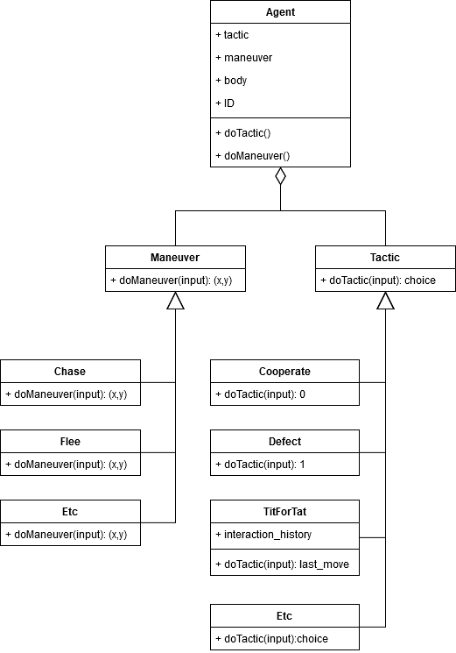
What does it entail to incorporate physics into the prisoner's dilemma? Unlike Axelrod's tournament, where agents are non-physical and solely represent tactics, my simulation also requires agents to have a physical representation, commonly referred to as a body. Furthermore, each agent needs a maneuver to dictate how the agent moves. These elements, along with the tactic, can then be grouped together and accessed by the agent’s unique ID.
When implementing maneuvers and tactics, I opted for the strategy pattern. It is imperative that each agent’s tactics and maneuvers be able to interact in a uniform manner with each other, while also allowing each algorithm to vary. This pattern encapsulates a set of algorithms and allows them to be interchangeable while enabling the underlying algorithm to vary. This approach can be likened to using Lego pieces: regardless of their color, shape, or size, they all connect seamlessly.
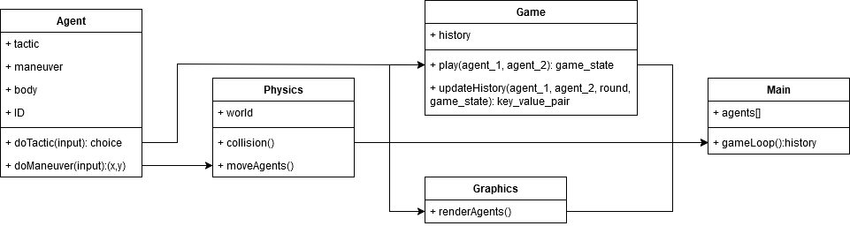
The simulation takes place within a "world”, a discrete space where a physics engine can be used to manipulate agent bodies. The physics engine is responsible for everything that happens in the world, including moving the agents, managing collisions, both between agent bodies and walls, and applying forces like gravity and friction. To better measure maneuver impact, gravity was removed, isolating agent maneuvers as the sole energy source in the system and ensuring all physics results stem directly from their maneuvers. To prevent agents from continuously accelerating, energy must also be removed from the system. Friction is effective for this purpose, functioning as a logarithmic maximum— as an agent accelerates, the drag from friction increases exponentially until a maximum speed is reached. This balance provides an excellent base to build the rest of the experiment on.
With the physics defined, how should games work? In Axelrod’s tournament, each agent plays against an opponent for a number of rounds, eventually playing against each agent. Agents have access to a history of their own moves, along with the history of the opponent they are playing against. In my simulation, opponents are variable instead of constant. Additionally, agents may play multiple agents at the same time if there are multiple collisions. This flexibility means that giving each agent a complete history of their opponents is not computationally feasible. To overcome this problem, I can give each agent a history of the games they have played in. This maintains the spirit of Axelrod’s tournament, while changing the computation costs from O(n^2*r) to O(n*r). These histories can be updated immediately after agents finish a game, resulting in individually small processing times.
Unlike Axelrod's tournament, which features static rounds, the simulation employs discretized time steps as rounds. This means that, instead of taking a snapshot of one agent interacting with another, we take a holistic snapshot of the simulation over a period of time. By using the simulation round and the IDs of colliding agents, we can then create a unique key for a hash map that stores game results. This setup enables O(1) time insertion and ensures minimal hash map values due to only four possible pairs of information. A system this efficient does not come without drawbacks. To avoid hashing collisions, only the first collision between two agents is recorded, which hinders simulation quality as we are unable to use sub steps. Despite this compromise, the tradeoff is justified as data storage is the primary bottleneck, and any improvement in this area enhances overall performance. We can further enhance the program by storing each agent in an array, where its ID is equal to its index number, again providing O(1) retrieval times. Additionally, to enrich user experience, we incorporate visuals into the simulation, utilizing a game loop to iterate through time steps before clearing and updating the display.
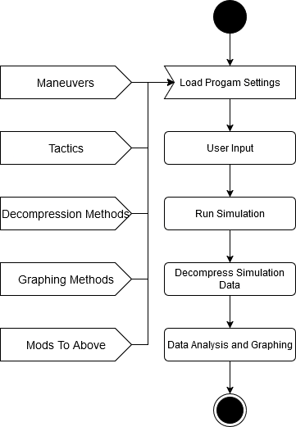
I designed the system to function as a framework that others could build upon, which requires it to be both efficient and highly modular. I planned for a base set of maneuvers, tactics, decompression methods, and graphing techniques to be included with the product, while also allowing for the addition of custom variations. The operation of the code itself would be straightforward: it starts by loading all settings, both predefined and custom. Users can then interact with these settings, such as enabling or disabling specific tactics or maneuvers, or modifying the physics engine. Following this configuration, the system runs the simulation and outputs a history object of every game played by the agents. This history can be decompressed for further data analysis and graphing, before the program terminates.

Implementation
For implementation, I wanted several benchmarks. For better, more predictable results, I wanted to be able to run the simulation with 1000 agents. Additionally, I wanted to be able to store at least 1 million data instances, while still processing them in less than 1 minute. I also wanted to ensure that as long as the initial conditions were the same, individuals would end up with identical results. Lastly, I wanted the system to be highly customizable to test a wide variety of experiments. In order to hit the performance benchmarks, while also providing the flexibility and control I needed, I decided to use C++. I also use box2D, a well-known 2-D rigid simulation library, to handle most of the collisions.
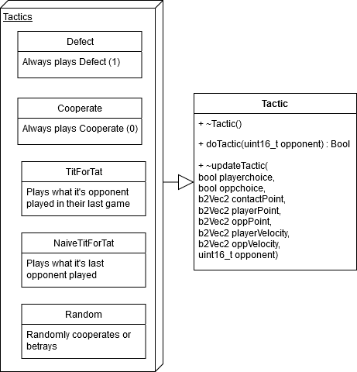
Agents have remained largely consistent, with a few significant changes. I replaced the terms "defect" and "cooperate" with 1 and 0 respectively, to reduce computation space and time. The primary difference involves the information given to agents. The amount of information accessible to agents was minimized for gameplay while maximizing their historical data utilization. In the Prisoner's Dilemma, agents make decisions without knowing the other player's intentions but are aware of their opponent's identity. To reflect this, I limited necessary information to just the identity of the opponent, which is crucial for developing adaptable, long-term strategies such as tit for tat. Moreover, I expanded the available information beyond that used in the traditional iterated Prisoner’s Dilemma. Agents can now base their decisions on a variety of new physics-related information, such as the contact point, agent positions, and the agent velocity vectors. Additionally, I provide several basic tactics for experimentation. These include Cooperate, which always returns 0, Defect which always returns 1, and RandomChoice, which returns 1 or 0 with equal probability.
Other than the basic tactics, I include two more advanced tactics. The Tit For Tat strategy typically has a memory of one move, as it replicates its opponent's last action. However, my version can interact with multiple agents. This complexity is managed by assigning an array, the length of which equals the total number of agents, where each agent's last interaction is stored at the index corresponding to its ID, with 0 (cooperate) as the default setting. I also developed a ‘naïve’ version of Tit For Tat that uses a single variable to store only the most recent interaction, instead of an array of interactions. This version does not mimic the last move of the current opponent, but rather the last opponent it faced. Consequently, if its last interaction was with a defecting agent, it will choose to defect in its next game, regardless of the new opponent’s behavior. Overall, This strategy functions as a mirror for the general behaviors of its environment.
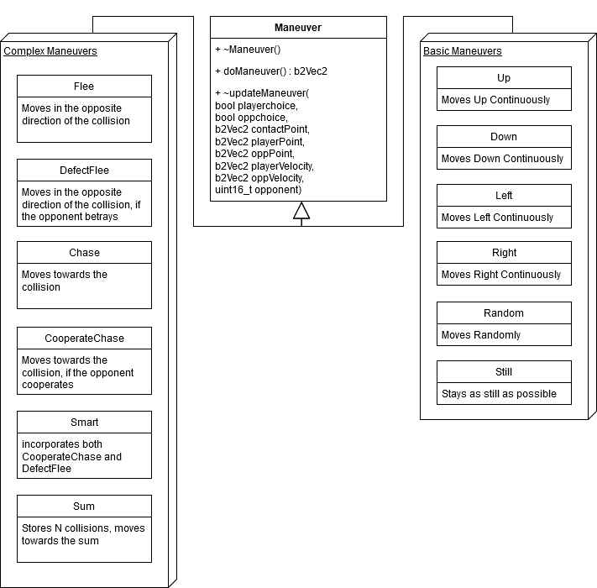
Maneuvers also mostly remained the same. Just like the tactics, I minimized the information available while playing the game and gave access to both game and physics data for its history. One element that did change is how I decided to move agents. I decided to use an impulse system that uses small, consistent pushes to accelerate agents instead of directly manipulating speed. This lightens the load on the collision solver and helps the simulation run smoothly. Additionally, instead of using the maneuvers to push the agents every time the agents collide, the maneuvers are applied to every agent at the end of the round. This avoids the problem of agents getting stuck if they end up in a zone with few agents to collide with and improves performance but does lead to an interesting behavior in agents that have logic. Since multiple collisions can happen in a single round, agents that have a low history depth ignore most of the collisions, using the latest collision to inform their movement. In agents with a history depth of 1, this can cause pairing. This pattern does not hold steady however, as numbers get higher, the average point begins to generalize and clumps get much larger than their history depth, mimicking herding behavior.
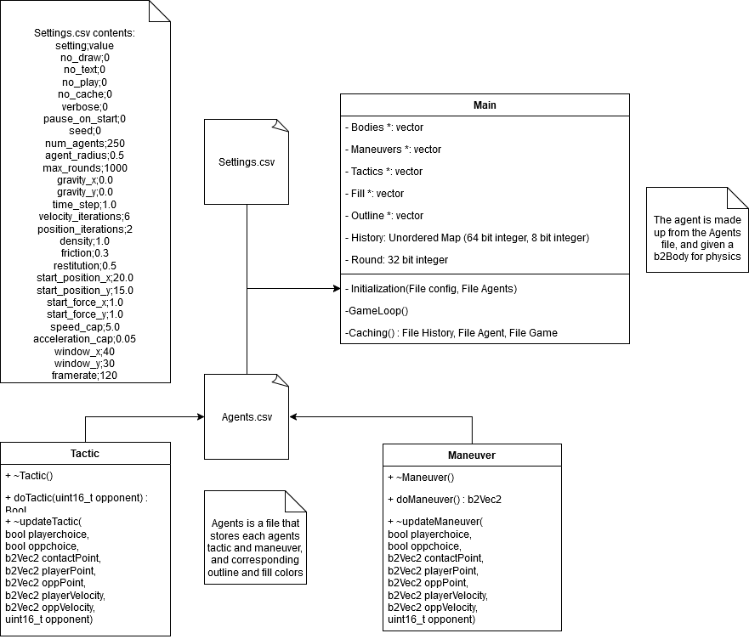
When it comes to the physics engine, I added several features between my concept and implementation, such as restitution and density. Restitution, which moderates the amount of energy maintained during collisions, is especially important. When restitution is not variable, the two possible implementations involve collisions returning 100% of the momentum or returning none of the momentum. If momentum is fully conserved, the impact of maneuvers is minimized as agents are pushed far away from each other. On the other hand, if agents retain no momentum from collisions, the impact of maneuvers is hard to discern. Lastly, I added a speed and acceleration cap, as agents that move too fast can cause collision problems.
The ability to customize simulation physics allows fine grained tuning for specific effects. I use several defaults to provide a good base experience if users are uninterested in modifying values. Gravity is set to 0, as most experiments are interested in primarily testing maneuvers. Density was also found to work best at 1 while agent radius of 0.5 was neither too large nor too small. Since agents move relatively slowly each simulation iteration, each step only needs 2 velocity steps and 2 position steps for proper results, although this can be made higher for improved accuracy. Lastly, the starting position of agents can be changed. Currently, I use a trickle in effect to minimize the number of starting collisions, where agents are spawned in the middle of the screen and pushed in random directions. Previously, I spawned all agents in at the same time, which would cause a large quantity of starting collisions to drastically slow the program.
These settings are stored in a file called Settings.CSV, which on initiation gets read into a set of constant variables. Of these variables, no_draw and no_text do not affect the simulation. There is one setting that should not change the results but do. While increasing the maximum number of rounds without changing any other results should not change the overlapping rounds, due to seed usage changing the maximum number of round changes initial collisions as well and leads to completely different results.
Additionally, Agents.CSV is a file that stores the agents by ID as an index, along with its maneuver and tactic, and their colors. Because these are in a file, individual or sets of agents can be manually replaced, deleted, or added to. While this does open the system to a possible breach, information read from these are not executed as code, and anything not in the accepted set of words throws an error, minimizing risk.
The history unordered map is an interesting object. To generate the key, I take a 32 bit round variable, and two 16 bit agent ID variables, before doing a simple left bitshift on each of them and storing the values in a 64 bit key. This process allows for both extremely fast insertions, being O(1) time and only taking 2 bitshifts, as well as extremely dense, with each key taking up only 64 bits while involving no hash collisions. I also managed to improve the value that is stored in the history function. Originally, I planned to store game results, meaning that I had to store two history instances, one for each agent. However, I discovered that storing a single game state, with only four possible values, was much more compact. This came with an additional requirement, however. To store the values together, I needed to know which agent was which for situations where one defected while the other cooperated. This can be fixed with minimal compute cost by ordering the ID’s numerically, ensuring that agent 1 always has a lower ID than agent 2. Using game states reduces the space required for values to just 2 bits, resulting in using the smallest numerical type which has a length of 8 bits, and can easily be decoded by comparing agent ID’s.
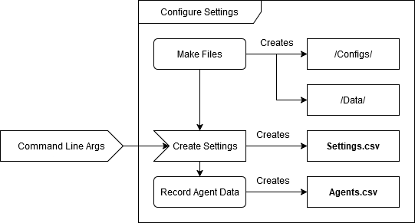
The first step to running the simulation is creating the Settings and Agents files that the main program uses to run. In addition to the command line argument options available in Settings.CSV, one can reset the maneuver and tactic constants, or select which of the predefined tactics and maneuvers are to be used for the simulation. The reset should only be used if maneuvers or tactics are to be permanently reset to the basic settings, as it removes any modified tactics or maneuvers. Once the command line arguments have been entered, the configs and data directories are created, if they do not already exist. These function as special directories that future programs search for, with the simulation using files in the configs directory to define its run time parameters and storing the resulting simulation history in the data directory. Additionally, data cleaning and graphing programs use the data directory to analyze and store information. Next, the command line arguments are read in and used to create the settings.csv file, which notably omits the arguments for modifying tactics and maneuvers, along with the constant reset argument. Lastly, reading the tactics and maneuvers to use, along with the num_agents setting, it creates a list of agents, using the seed to randomly determine which agents have which features, and saves this to the Agents.csv file.
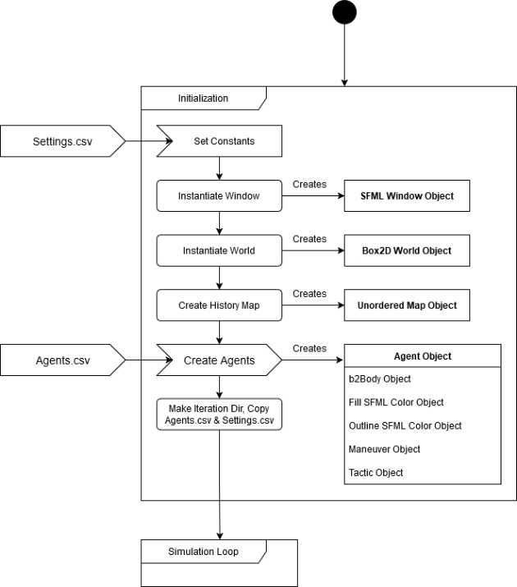
The simulation begins with the initialization process. We start by reading the settings.csv file, and transferring its values to a list of constants used throughout the simulation. Next, we initialize core components including the simulation viewing window, the physics engine (world), and the history object. We then read the agents.csv file to create agents, assigning values to five interconnected arrays: the B2body (which interacts with physics), the Maneuver and its associated Fill color, and the Tactic with its corresponding Outline color. The final step of initialization involves creating a directory for this simulation instance in the data directory labelled iteration_number. The number is an auto generated value depending on how many other simulation histories are stored. The file is used to store results and the settings.csv and agents.csv files are copied into it for reproducibility.
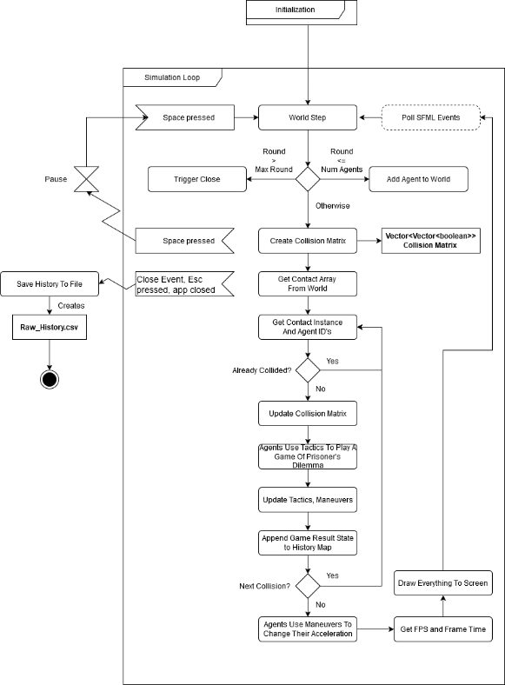
The simulation starts by executing a world step, which advances the simulation time. This involves updating the velocities of each agent during the velocity step using friction and restitution, and updating the positions of agents based on their movement and if they overlap. Next, depending on the current round, one of three scenarios unfolds: if the round is less than or equal to the total number of agents, a new agent is added to the center of the world and pushed in a random direction. If the round exceeds the number of agents but is less than the maximum, the process transitions to managing collisions. A collision matrix is established to ensure each pair of agents only plays one game of the prisoner’s dilemma once per round, maintaining fairness between tactics and maneuvers. After the simulation step, we can access the collisions that occurred that round from the world via the contact list.
The next step is to iterate through the list of object contacts, retrieving the ID’s of the involved agents. If the value at the matrix position of the two agent ID’s is 0, representing false, we update it to 1, representing true, and move into the game loop. Here, we retrieve physics information like the agent points and velocity vectors, and allow the agents to use their tactics, resulting in two agent choices. We then update the maneuvers and tactics using the new game choices and physics data. When updating the history, I first ensure that the agent ID’s are ordered numerically. To create the key, I take the two 16 bit Agent ID’s and the 32 bit Round variable and, using left bitshifts, merge these values into a 64 bit key. Likewise, I take the two 1 bit choice variables and bitshift them, storing them in the smallest variable type and using only 8 bits total. This results in each game instance only taking up 72 bits, which then gets added to the history map. If further collisions are detected in the contact manifold, the simulation revisits this step; if not, it progresses to the maneuver phase where agents adjust their accelerations. Performance is monitored by capturing frames per second (FPS) and frame time before rendering the scene on the screen. Additionally, SFML events are polled to respond to user inputs like window closures or key presses. If the red X is clicked, the escape key is pressed, or the round reaches the maximum limit, the window closes and the simulation saves the history data, formatted as a CSV file, in the iteration directory. Pressing the spacebar pauses the simulation, which resumes only when the spacebar is pressed again.
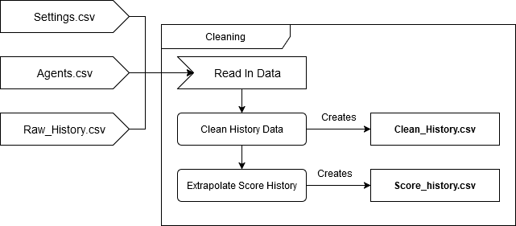
In order to use the data for visualization and analysis, it first must be cleaned from its raw form. To do this, we start by converting the settings, agents, and raw_history csv files to pandas dataframes. The first cleaning step is deciphering the key value pairs, which can be done by reversing the bitshifts that were initially done. This operation results in 5 values, the two agent ID’s involved in the collision, the round in which the collision happened, and the choices of each agent. Next, we run each agent’s decisions through the reward matrix, calculating the rewards that each agent received each game. Because we do this after the simulation step, changing the reward matrix has no impact on the simulation results. We also create a score history dataframe, which is used to store each agents score each round. Because agents can collide multiple times per round, we have to calculate the cumulative points an agent earned across every game that occurred that round. From there, we extract the strategies and colors, connecting them with the agents that use those strategies. Lastly, we take the decoded history, scores, and strategies and colors, concatenating them into one dataframe and ordering them by round and agent ID. We then repeat this process for the score history. This data is then stored in the corresponding data iteration directory.
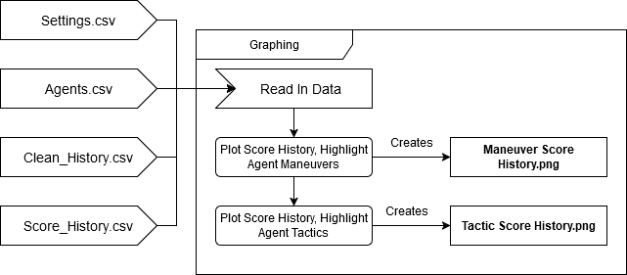
Finally, in order to visualize the data, we take the settings and agents files, along with our new clean history and score history, and read those into pandas dataframes. The first plot involves the score history of every agent, organized by the color of their tactic. This graph represents how impactful the agents tactic was for gaining points. Next, we get the average score of each tactic, providing a general overview of how each tactic performed relative to other tactics. We then repeat this process for maneuvers, saving each graph as a png file in the corresponding data iteration directory.

Results
The results of the simulation offer profound insight and depth into how the prisoner's dilemma can work in an environment involving movement. Before diving into the results, I want to explain some of the quirks of the process. Most graphs follow the pattern of an initial acceleration of points, followed by a second surge before the rate begins to steady. The initial spike is due to the agents colliding in bulk, as the trickle effect ends and the agents begin to move. The second large spike in the rate of point accumulation is when many agents hit the walls, causing them to bounce back and collide with each other. Overall, I have found that the real results of the simulation tend to take place after round 1000, and can sometimes take thousands of rounds to settle into a pattern. For the following results, I use simulations with 300 agents, that run for 10,000 rounds. I use 7 for seed, as it results in a minimally impactful agent ratio of 100 Cooperate, 102 Tit For Tat, and 98 Defect agents. Additionally, these simulations take place in a space that is 1440 pixels wide (48 window_x) and 810 pixels tall (27 window_y), which is the same ratio of 16:9 as most monitors.
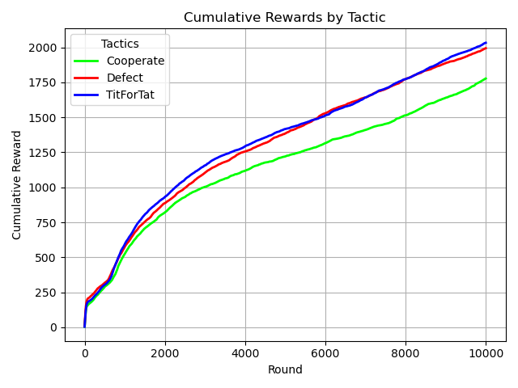
To see if the simulation’s results were accurate, I wanted to compare it against Axelrod’s tournament using simple tactics. Since there are approximately equivalent ratios of each tactic, if agents move randomly, they should have equal odds of running into any other tactic, similar to a round robin tournament. This should result in defect and Tit For Tat being similarly scored, with Defect taking a slight early lead for its initial reactions with Tit For Tat, and cooperate trailing behind. This is exactly what happens, Defect even spikes between rounds 0 and 500 because of the initial Tit For Tat collisions. But why does Tit For Tat end up doing slightly better than Defect? While the ratio is close to equal, there are two extra Tit For Tat agents and two less Defect agents, adding a slight boost in points to cooperative strategies.
Now that the simulation results have been shown to be decently accurate, we can explore the main reason I created this simulation, which was to see if maneuvers were more impactful than tactics. To test if maneuvers have any impact, I use a simulation where the tactic is set to random, and I compare this with three maneuvers: Random, Chase, and Flee. Because the impulses applied are small each round, agents that move randomly stay approximately in the same place. Chase, on the other hand, when it collides with another agent, will move towards the collision point. Flee, of course, does the opposite, leading to some interesting results. Next, I compare these maneuvers against Tit For Tat, Defect, and Cooperate to see if they are more impactful than Tit For Tat.
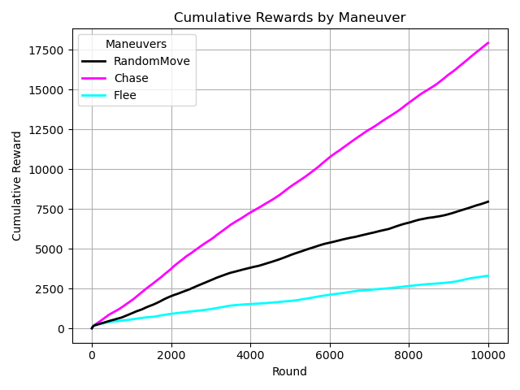
As we can see, Maneuver has a clear impact on score. The data shows a clear correlation: the more an agent moves towards other agents, the more score they will receive. This is so prevalent that moving randomly is a better strategy for gaining points than moving away from collisions. This does make sense, however. Since agents get points only when they collide with each other, agents that avoid collisions take the equivalent of the Sucker’s payoff each round they are not colliding, leading to overall terrible scores.
Not participating is a variable that is not defined in the original prisoner’s dilemma. In this simulation, it will be referred to as C, the cost of not participating, and will remain 0, as this best represents getting nothing out of an interaction. However, it should still be more valuable than the more punishing effects, such as the Punishment for mutual defection or the Suckers payoff. With this in mind, I propose the new underlying inequality becomes T > R > C > P > S, with C being 0.
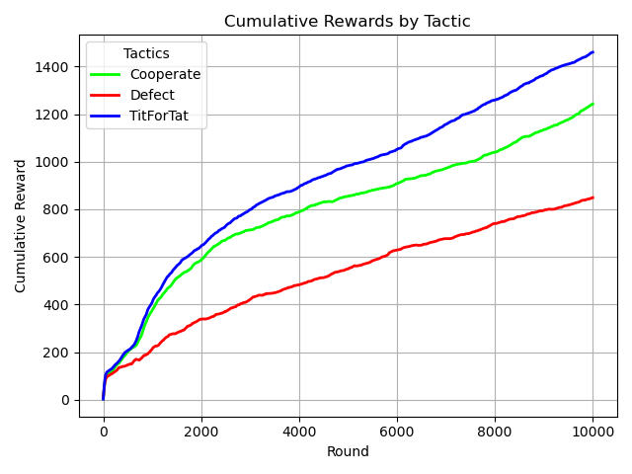
The impact of these changes can be seen by re-running the first test, with a new payoff matrix. I use the payoffs T = 5, R = 3, C = 0, P = -1 and S = -2 as this changes the matrix minimally, while still following all the rules of the prisoner’s dilemma and providing heavier punishment for defection. Cooperate earns 1777 points in the original payoff matrix and 1242 points from the new matrix, losing 535 points. Similarly, Defect earns 1993 points in the first round, and 849 points in the second round, losing 1,144 points. Tit For Tat is the least effected, earning 2032 points in the first round, followed by 1459 points in the second round, only losing 573. Tit for tat loses 28.2% of its points, Cooperate loses 30.1% of its points, and defect loses a staggering 57.4% of its final score.
These results accurately reflect the impact of changing the matrix. Defect agents take a large penalty, as the reward for interacting with itself and Tit For Tat changed from 1 to -1. This changes the average score of interactions from 7 (1 from itself, 1 from tit for tat, and 5 from cooperate) to 3 (-1 from itself, -1 from tit for tat, and 5 from cooperate). Cooperate also takes a hit, as its average drops from 6 (0 from defect, 3 from itself and tit for tat) to 4 ( -2 from defect, 3 from itself and tit for tat). Tit for tat is the least impacted, as its score changes from 7 to 5 (1 from defect to -1 from defect, 3 from itself and cooperate).
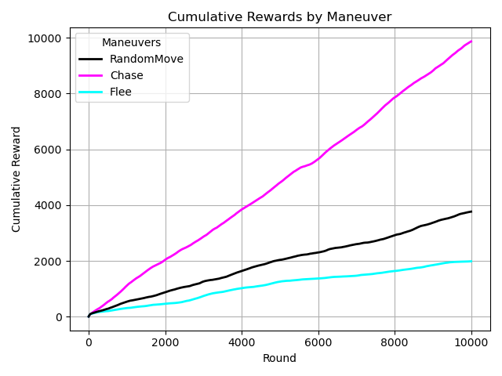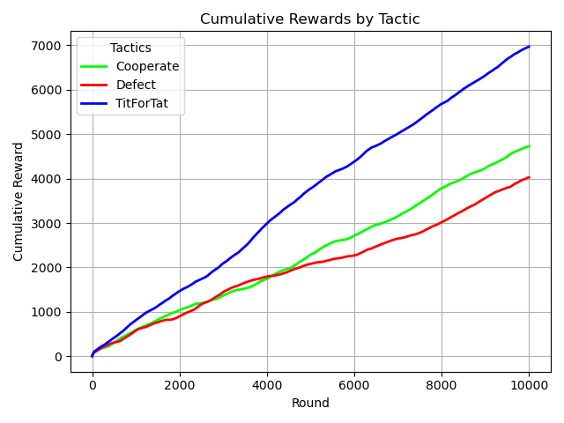
From the results, we can see that maneuver is more impactful overall than tactic. But that tactic still plays a significant role in point gain. This is because the difference between maneuvers is higher than the difference between tactics. For maneuvers, Chase earned 9867 points on average, Flee earned 1986 points, and RandomMove earned 3767. On the other hand, Tit For Tat earned exactly 6969 points, Cooperate earned 4727 points, and Defect earned 4027 points. Because the difference of scores relative to each other is higher for maneuvers, I am inclined to believe that movement still is the primary source for point generation, showing that its not how agents play the game, its how often they play that matters.

Conclusion
The prisoner’s dilemma is an incredible game theory. Even though the model appears simple, it provides a basis for deep insight into how people make decisions. Robert axelrod’s tournament compounded on this by studying how individuals learn from past experiences and proved to the world that it pays to be nice with his computer tournament. His work inspired me to add a dimension of my own, as I wanted to see how individuals make decisions about how they play and move in spatial dimensions. To this end I created a computer program to simulate, analyze, and graph the results of this new model, with some fascinating implications for the outcomes.
In my exploration, I learned that managing huge datasets would be one of the largest problems to solve. As a result, I developed an extremely efficient and compact data storage system, capable of running in O(1) time and involving only 4 bit shifts. Designing the physics engine and connecting it to the game system was also difficult. To this end I used the strategy pattern, which turned out to be a perfect fit.
The results shed new light on how individuals interact in communities. When it comes to accumulating score, how agents move is more important than how agents act. This also reinforces the robustness of tit for tat, which does well in tournament-esque interactions and environments that punish defection.
I believe that there is much more to be done with this concept. The first thing I would improve is its usability, primarily through an interactive GUI. When I began creating this tool, I envisioned it as easy to use, regardless of discipline, and visuals would be a large improvement towards this goal. Additionally, I want to broaden the scope of the program to evolution and mutation, which would allow individuals to see how populations change over time. Lastly, there are some technical improvements I would make to heighten the performance and efficiency. These primarily involve transitioning data processing to C++ instead of python, along with enhancing the physics engine to run simulations more smoothly and quickly.

Works Cited
Axelrod, R., & Axelrod, R. M. (1984). The Evolution of Cooperation. Basic Books.
Poundstone, W. (1992). Prisoner’s Dilemma. Doubleday.
Prisoner’s dilemma. (2024). In Wikipedia. https://en.wikipedia.org/w/index.php?title=Prisoner%27s_dilemma&oldid=1261195520

